FORM 3 At yarışı kodları

using System;

using System.Collections.Generic;

using System.ComponentModel;

using System.Data;

using System.Drawing;

using System.Linq;

using System.Text;

using System.Threading.Tasks;

using System.Windows.Forms;

using System.Threading;

namespace WindowsFormsApp1

{

public partial class Form3 : Form

{

public Form3()

{

InitializeComponent();

}

Random r = new Random();

Thread sayma,athareket,athareket2,athareket3;

void metot1()

{

progressBar1.Maximum = 100;

progressBar1.Minimum = 0;

progressBar1.Value = 100;

while (true)

{

progressBar1.Value =progressBar1.Value-1;

label9.Text = "Yarış başlıyor...." + progressBar1.Value.ToString();

Thread.Sleep(30);

if (progressBar1.Value == 0)

{

button3.Width = 138;

button3.Height = 13;

button3.Left = 120;

button4.Width = 138;

button4.Height = 13;

button4.Left = 120;

button5.Width = 138;

button5.Height = 13;

button5.Left = 120;

athareket = new Thread(new ThreadStart(athareketmetot));

athareket2 = new Thread(new ThreadStart(athareketmetot2));

athareket3= new Thread(new ThreadStart(athareketmetot3));

athareket3.Start();

athareket2.Start();

athareket.Start();

label9.Visible = false;

sayma.Abort();

}

}

}

void atkontrol()

{

if (pictureBox1.Left > pictureBox2.Left && pictureBox1.Left > pictureBox3.Left)

{

label5.Text = "3 numaralı at";

if (pictureBox2.Left > pictureBox3.Left)

{

label6.Text = "4 numaralı at";

}

else

{

label7.Text = "6 numaralı at";

}

}

else if (pictureBox1.Left > pictureBox2.Left && pictureBox1.Left < pictureBox3.Left)

{

label5.Text = "6 numaralı at";

label6.Text = "3 numaralı at ";

label7.Text = "4 numaralı at";

}

else if (pictureBox1.Left < pictureBox2.Left && pictureBox1.Left > pictureBox3.Left)

{

label5.Text = "4 numaralı at";

label6.Text = "3 numaralı at ";

label7.Text = "6 numaralı at";

}

else if (pictureBox1.Left < pictureBox2.Left && pictureBox1.Left < pictureBox3.Left)

{

label7.Text = "3 numaralı at";

if (pictureBox2.Left > pictureBox3.Left)

{

label6.Text = "4 numaralı at";

}

else

{

label7.Text = "6 numaralı at";

}

}

}

void athareketmetot()

{

while (true)

{

int random = r.Next(1, 5);

pictureBox1.Left +=random;

Thread.Sleep(30);

atkontrol();

if (pictureBox1.Left > 1192)

{

athareket.Abort();

}

}

}

void athareketmetot2()

{

while (true)

{

int random = r.Next(1, 5);

pictureBox2.Left += random;

Thread.Sleep(30);

atkontrol();

if (pictureBox2.Left > 1192)

{

athareket2.Abort();

}

}

}

void athareketmetot3()

{

while (true)

{

int random = r.Next(1, 5);

pictureBox3.Left += random;

Thread.Sleep(30);

atkontrol();

if (pictureBox3.Left > 1192)

{

athareket3.Abort();

}

}

}

void izinal()

{

Form1.CheckForIllegalCrossThreadCalls = false;

sayma = new Thread(new ThreadStart(metot1));

sayma.Start();

}

private void Form3_Load(object sender, EventArgs e)

{

label1.Text = Form2.kisiad;

}

private void button1_Click(object sender, EventArgs e)

{

izinal();

}

}

}

FORM 3 GÖRÜNÜMÜ

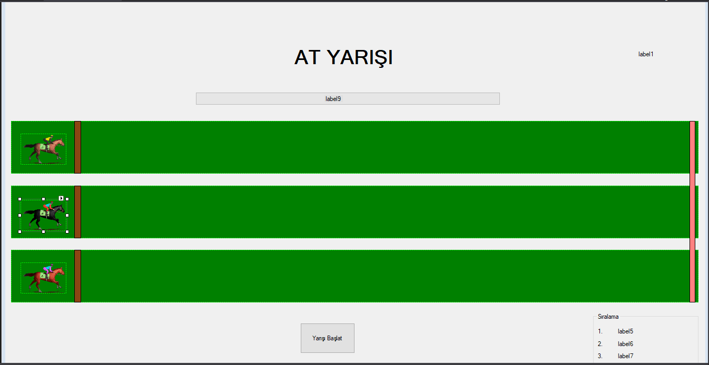

FORM 2 KODLARI

using System;

using System.Collections.Generic;

using System.ComponentModel;

using System.Data;

using System.Drawing;

using System.Linq;

using System.Text;

using System.Threading.Tasks;

using System.Windows.Forms;

using System.Data.SqlClient;

namespace WindowsFormsApp1

{

public partial class Form2 : Form

{

public Form2()

{

InitializeComponent();

}

SqlConnection baglanti = new SqlConnection("Data Source=localhost;Initial Catalog=atyarisi;Integrated Security=True");

SqlCommand cm = new SqlCommand();

public static string kisiad;

private void Form2_Load(object sender, EventArgs e)

{

baglanti.Open();

cm = new SqlCommand("select saha_ad from saha",baglanti);

SqlDataReader dr;

dr = cm.ExecuteReader();

while (dr.Read())

{

comboBox1.Items.Add(dr["saha_ad"]);

}

cm.Dispose();

baglanti.Close();

}

private void textBox1_TextChanged(object sender, EventArgs e)

{

listBox1.Items.Clear();

baglanti.Open();

cm = new SqlCommand("select * from jokey where j_ad like '%"+textBox1.Text+"%' ", baglanti);

SqlDataReader dr;

dr = cm.ExecuteReader();

while (dr.Read())

{

listBox1.Items.Add(dr["jokey_id"] +"."+ dr["j_ad"]);

}

baglanti.Close();

}

private void listBox1_Click(object sender, EventArgs e)

{

listBox2.Items.Clear();

string j_adno = listBox1.SelectedItem.ToString();

string[] dizi = j_adno.Split('.');

int jokey_no = Convert.ToInt32(dizi[0]);

textBox1.Text = dizi[1];

baglanti.Open();

cm = new SqlCommand("select at_ad,durumu from at as AT where jokey_id='"+jokey_no+"' ",baglanti);

SqlDataReader dr;

dr = cm.ExecuteReader();

while (dr.Read())

{

listBox2.Items.Add(dr["at_ad"]+" "+dr["durumu"]);

}

cm.Dispose();

baglanti.Close();

}

private void button1_Click(object sender, EventArgs e)

{

if(textBox1.Text==string.Empty || textBox2.Text == string.Empty || textBox3.Text == string.Empty || textBox4.Text == string.Empty || comboBox1.Text == string.Empty)

{

MessageBox.Show("Boş Alan Bırakmayınız");

}

else if(label18.Text == "Seçilen At" || int.Parse(textBox4.Text)>18)

{

MessageBox.Show("lütfen bir at seçiniz");

}

else

{

baglanti.Open();

cm = new SqlCommand("select jokey_id from jokey where j_ad='"+textBox1.Text+"'", baglanti);

int j_id=Convert.ToInt32(cm.ExecuteScalar());

cm = new SqlCommand("select at_id from at where at_ad='" + label18.Text + "'", baglanti);

int at_id = Convert.ToInt32(cm.ExecuteScalar());

cm = new SqlCommand("select saha_id from saha where saha_ad='"+comboBox1.Text+"' ", baglanti);

int saha_id = Convert.ToInt32(cm.ExecuteScalar());

cm = new SqlCommand("insert into oyuncu (ad,yas,jokey_id,saha_id,yatirim,at_id) values ('" + textBox2.Text + "'," + int.Parse(textBox4.Text) + ","+j_id+","+saha_id+","+int.Parse(textBox3.Text)+","+at_id+") ", baglanti);

cm.ExecuteNonQuery();

cm.Dispose();

baglanti.Close();

MessageBox.Show("Oyuncu kimliğiniz oluşturulmuştur.");

kisiad = textBox2.Text;

Form3 fm3 = new Form3();

this.Hide();

fm3.Show();

}

}

private void listBox2_Click(object sender, EventArgs e)

{

string listbox = listBox2.SelectedItem.ToString();

string[] dizi = listbox.Split(' ');

label18.Text = dizi[0];

}

}

}

FORM GÖRÜNÜMÜ

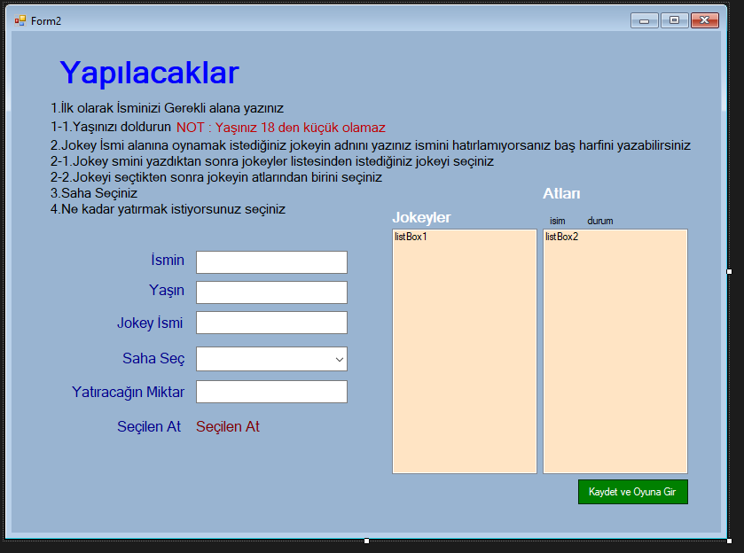

FORM 1 KODLARI

using System;

using System.Collections.Generic;

using System.ComponentModel;

using System.Data;

using System.Drawing;

using System.Linq;

using System.Text;

using System.Threading.Tasks;

using System.Windows.Forms;

using Microsoft.Win32;

namespace WindowsFormsApp1

{

public partial class Form1 : Form

{

public Form1()

{

InitializeComponent();

}

private void Form1_Load(object sender, EventArgs e)

{

button2.Enabled = false;

label3.Visible = false;

Registry.CurrentUser.CreateSubKey("AtYarışı").CreateSubKey("Lisans").SetValue("LisansŞifresi", "0000");

Registry.CurrentUser.CreateSubKey("AtYarışı").CreateSubKey("Lisans").SetValue("Eposta", "dogukanyilmazzz@hotmail.com");

}

private void button1_Click(object sender, EventArgs e)

{

string sifre = textBox1.Text;

string lisanskey = Registry.CurrentUser.OpenSubKey("AtYarışı").OpenSubKey("Lisans").GetValue("LisansŞifresi").ToString();

string lisansposta = Registry.CurrentUser.OpenSubKey("AtYarışı").OpenSubKey("Lisans").GetValue("Eposta").ToString();

string eposta = textBox2.Text;

if (sifre == lisanskey && eposta == lisansposta)

{

label3.ForeColor = Color.Green;

label3.Visible = true;

label3.Text = "License Complated";

button2.Enabled = true;

}

else

{

label3.Visible = true;

label3.ForeColor = Color.Red;

label3.Text = "Failed Login";

MessageBox.Show("Yanlış şifre veya eposta adresi");

}

}

private void button2_Click(object sender, EventArgs e)

{

Form2 fm2 = new Form2();

this.Hide();

fm2.Show();

}

private void button3_Click(object sender, EventArgs e)

{

Form3 fm3 = new Form3();

fm3.Show();

this.Hide();

}

}

}

FORM 1 GÖRÜNÜMÜ

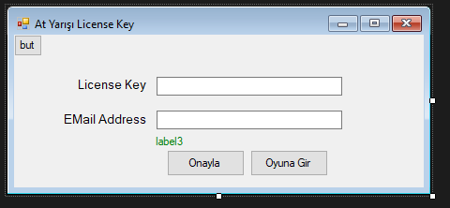

DATABASE GÖRÜNTÜSÜ

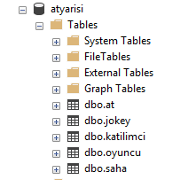

KODLARI

AT TABLOSU KODLARI :

USE [atyarisi]

GO

/****** Object: Table [dbo].[at] Script Date: 7.12.2018 00:53:55 ******/

SET ANSI_NULLS ON

GO

SET QUOTED_IDENTIFIER ON

GO

CREATE TABLE [dbo].[at](

[at_id] [int] IDENTITY(1,1) NOT NULL,

[at_ad] [nvarchar](50) NULL,

[durumu] [nvarchar](50) NULL,

[jokey_id] [int] NULL

) ON [PRIMARY]

GO

JOKEY TABLOSU KODLARI

USE [atyarisi]

GO

/****** Object: Table [dbo].[jokey] Script Date: 7.12.2018 00:54:37 ******/

SET ANSI_NULLS ON

GO

SET QUOTED_IDENTIFIER ON

GO

CREATE TABLE [dbo].[jokey](

[jokey_id] [int] IDENTITY(1,1) NOT NULL,

[j_ad] [nvarchar](50) NULL,

[k_puan] [tinyint] NULL

) ON [PRIMARY]

GO

KATILIMCI TABLOSU

USE [atyarisi]

GO

/****** Object: Table [dbo].[katilimci] Script Date: 7.12.2018 00:54:59 ******/

SET ANSI_NULLS ON

GO

SET QUOTED_IDENTIFIER ON

GO

CREATE TABLE [dbo].[katilimci](

[katilimci_id] [int] IDENTITY(1,1) NOT NULL,

[kad] [nvarchar](50) NULL,

[kyas] [tinyint] NULL

) ON [PRIMARY]

GO

OYUNCU TABLOSU

USE [atyarisi]

GO

/****** Object: Table [dbo].[oyuncu] Script Date: 7.12.2018 00:55:25 ******/

SET ANSI_NULLS ON

GO

SET QUOTED_IDENTIFIER ON

GO

CREATE TABLE [dbo].[oyuncu](

[oyuncu_id] [int] IDENTITY(1,1) NOT NULL,

[ad] [nvarchar](50) NULL,

[yas] [nchar](10) NULL,

[jokey_id] [int] NULL,

[saha_id] [int] NULL,

[yatirim] [int] NULL,

[at_id] [int] NULL

) ON [PRIMARY]

GO

SAHA TABLOSU

USE [atyarisi]

GO

/****** Object: Table [dbo].[saha] Script Date: 7.12.2018 00:55:55 ******/

SET ANSI_NULLS ON

GO

SET QUOTED_IDENTIFIER ON

GO

CREATE TABLE [dbo].[saha](

[saha_id] [int] NULL,

[saha_ad] [nvarchar](50) NULL,

[renk] [nvarchar](50) NULL

) ON [PRIMARY]

GO